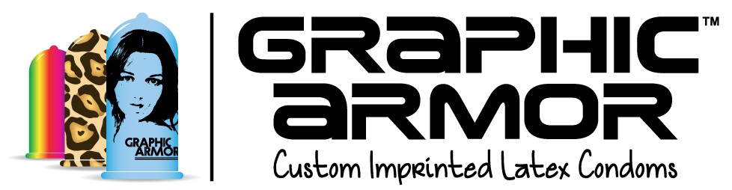
Contact:
Adam Glickman
323-230-0201
Adam@GraphicArmor.com

FOR IMMEDIATE RELEASE

GRAPHIC ARMOR™ LAUNCHES THE WORLD’S FIRST CONDOMS TO FEATURE CUSTOM PRINT ON THE LATEX

Design competition has garnered entries from over 30 countries vying to design the world’s first Tattoo Condoms™.

LOS ANGELES, October 21, 2014. In an effort to change the way people look at condoms by changing the way condoms look, Graphic Armor™ (http://www.GraphicArmor.com) is offering FDA-approved condoms that, for the first time, feature custom printed images, words, slogans and “tattoos” printed directly onto the latex. The company’s Tattoo Condom Design Contest has invited designers, tattoo artists, and those who see the human body as a potential canvas to enter a competition to design the world’s first Tattoo Condoms™. Today Graphic Armor announced early results from the contest demonstrating the power of this new technology, with over 13,000 votes cast for 140 entries from over 30 countries, including Iran, China, Brazil, Latvia and South Africa. It’s a whole new way to let your flag fly!

The Tattoo Condom Design Contest (http://www.graphicarmor.com/tattoo-condom-design-contest.html) is open to everyone, and winners will be determined by the voting public. The winning entries will be printed on premium latex condoms for international sale -- all of Graphic Armor’s imprinted condoms are FDA approved, exceeding safety and regulatory standards around the world. Each winner also will get a cash prize and a bunch of Tattoo Condoms.

Graphic Armor’s Adam Glickman notes, “We’re not just offering a new product, we’re offering a new mindset, a new way of looking at an old product to change attitudes and behavior.” Glickman, who previously founded America’s first condom store, Condomania, 23 years ago continues, “Over the last 20 years, we’ve seen that offering consumers choices and even personalized packaging in condoms with logos or humor helps to increase condom usage. This new technology of custom printing right on the latex has the potential to overcome obstacles that have hampered condom use globally for decades. There are still far too many people who are unwilling to even try on a condom based on misinformation or negative perceptions about how condoms feel, and young people who dismiss the importance of practicing safer sex. If we can entice someone to put on a condom because it has a clever or cool design, we can impact real social change.”

The Tattoo Condom Design Contest is open for submissions until November 1, 2014 with voting until November 12, 2014.

About Graphic Armor™
Graphic Armor’s (http://GraphicArmor.com) mission is to change the way people look at condoms by changing the way condoms look with custom imprinted latex. Whether you want to adorn your condom in leopard print, promote your company in a whole new way, or celebrate your loved one with a special tribute, they have the answer. Condoms can be designed and ordered in Graphic Armor’s Design Studio™ with a minimum order of just 33 condoms.

Graphic Armor has launched a crowdfunding campaign at RocketHub (http://rkthb.co/44380), with a portion of proceeds supporting health agencies around the world promote condom usage.

###

