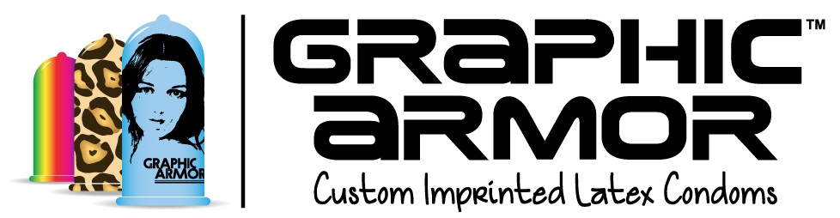
Contact:
Adam Glickman
323-230-0201
Adam@GraphicArmor.com

FOR IMMEDIATE RELEASE

GRAPHIC ARMOR™ LAUNCHES THE WORLD’S FIRST
CUSTOM PRINTED LATEX CONDOMS

French Lingerie Designer Britta Uschkamp Wins Tattoo Condom Design Contest Besting Entries from 33 Countries

LOS ANGELES, November 20, 2014. In an effort to change the way people look at condoms by changing the way condoms look, Graphic Armor™ (http://www.GraphicArmor.com) is offering FDA-approved condoms that, for the first time, feature custom printed images, words, slogans and “tattoos” printed directly onto the latex. Last month, the company’s Tattoo Condom Design Contest invited designers and tattoo artists to look at the human body as a potential canvas and design the world’s first Tattoo Condoms™. The competition resonated all over the world, attracting 31,875 votes for 164 designs from 33 countries.

Today Graphic Armor announces the winner of the competition with over 10,000 votes: Paris-based Lingerie Designer Britta Uschkamp (http://brittauschkamp.com). Britta is best known for her popular scarf- and ribbon-based playsuits.

Britta’s winning floral print design is called ‘Fleurs-2-Bite’ and is meant as a tongue-in-cheek interpretation of the fleurs-de-lis, the traditional symbol of the French political and religious elite.

“The concept is a visual of male flirting behaviors, such as giving flowers and compliments, as a pretext for sex,” said Britta. “Look closely and behind every flower, you can see the symbol of male power in the design.”

Britta first developed the print a decade ago while studying at the Institute Français de la Mode, and created some sample lingerie pieces in silk muslin georgette. Producing the multi-colored print on such a fine fabric proved too costly, however, and she put it aside with thoughts of one day turning it into embroidery or lace.

“The condom contest was simply great timing,” she said, “as it is a clin d’oeil (translation: ‘wink’) to the feminist concept of the print, and offers me an opportunity to finally market this beautiful, cheeky design.”

Uschkamp’s winning design will be printed on Graphic Armor’s premium latex condoms for international sale -- all of Graphic Armor’s imprinted condoms are FDA approved, exceeding safety and regulatory standards around the world.

Graphic Armor’s Adam Glickman notes, “We’re not just offering a new product, we’re offering a new mindset, a new way of looking at an old product to change attitudes and behavior.” Glickman previously founded America’s first condom store, Condomania, in 1991. He continued, “This new technology of custom printing right on the latex has the potential to overcome obstacles that have hampered condom use for decades. If we can entice someone to put on a condom because it has a clever or cool design like Britta’s, we can impact real social change and global public health.”

About Graphic Armor™
Graphic Armor’s (http://GraphicArmor.com) mission is to change the way people look at condoms by changing the way condoms look with custom printed latex. Whether you want to adorn your condom in leopard print, promote your company in a whole new way, or celebrate your loved one with a special tribute, we have the answer. Condoms can be designed and ordered in Graphic Armor’s Design Studio™ with a minimum order of just 33 condoms.

Graphic Armor has launched a crowdfunding campaign at RocketHub (http://rkthb.co/44380), with a portion of proceeds supporting health agencies around the world promote condom usage.

###

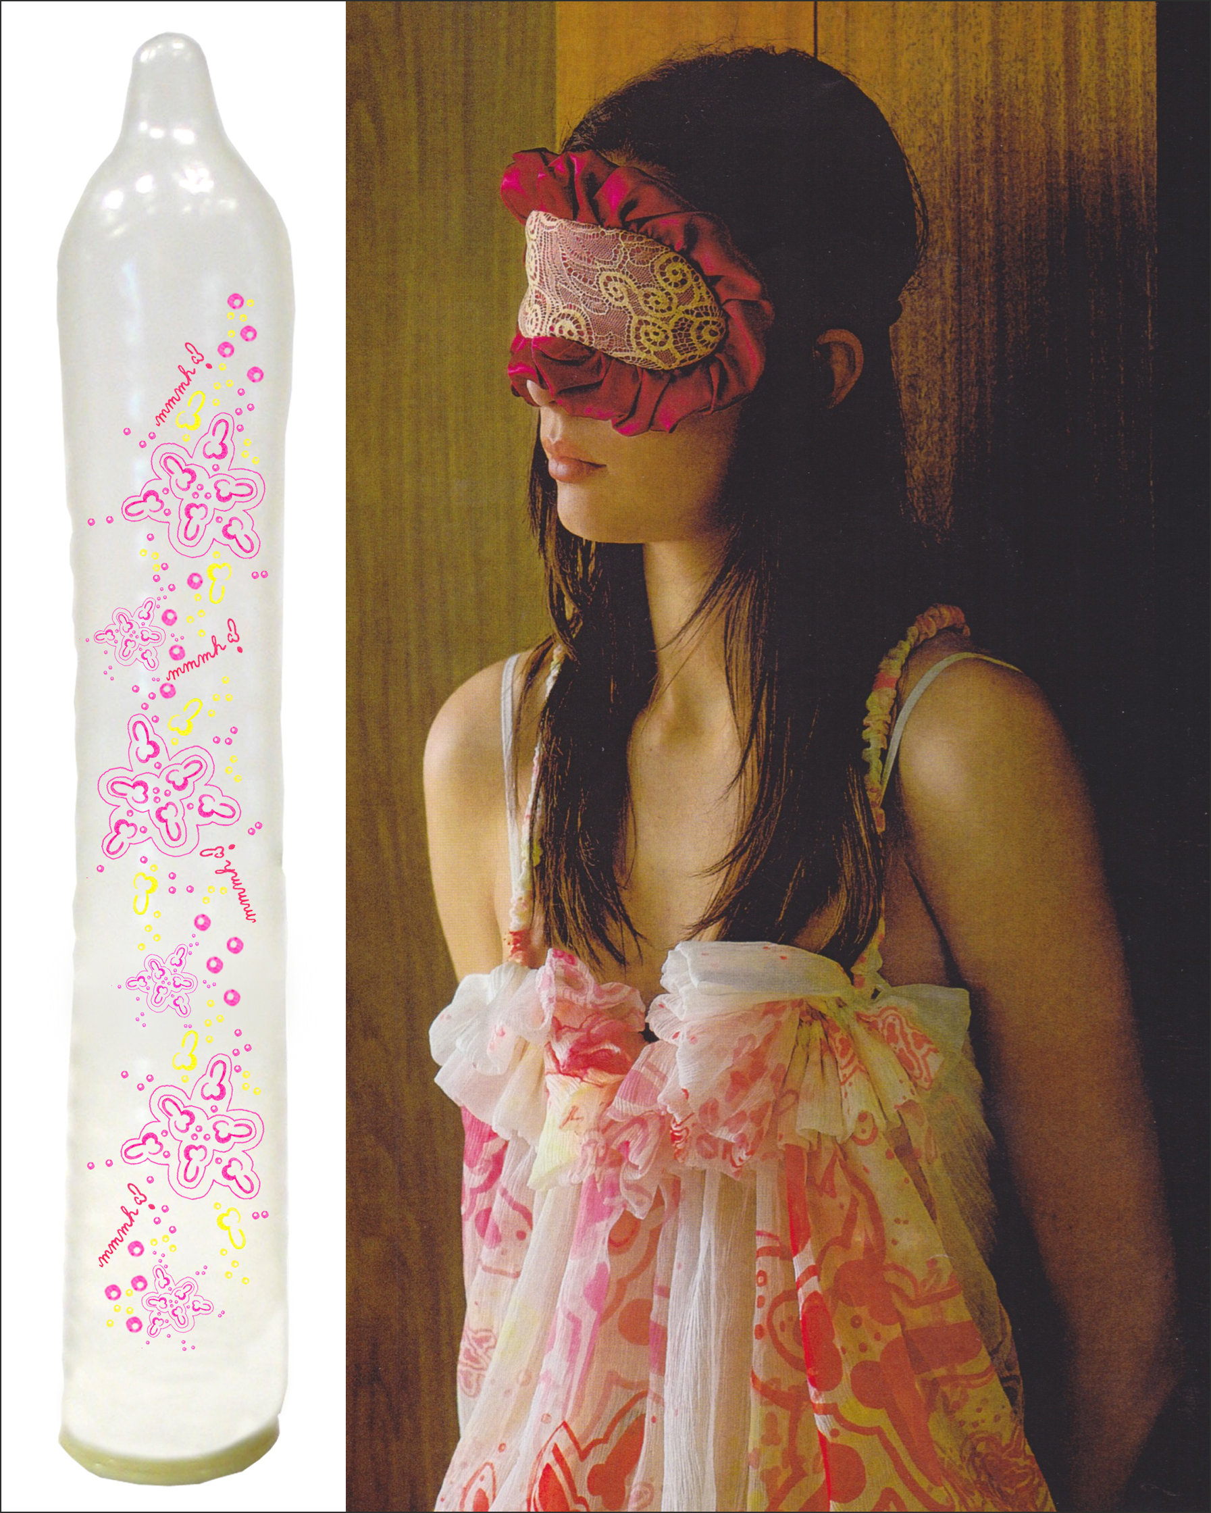

Photo credit of lingerie model: Olivier Metzger

